**REQUEST PROCESSING**

**Request Transformation**

The Request Transformation policy can be used to modify the contents of an incoming request such as headers, payload, query parameters, path parameters, HTTP method using the configurations given by the API Provider. The below diagram represents the flow of "Request Transformation" policy usage for transforming the request contents.

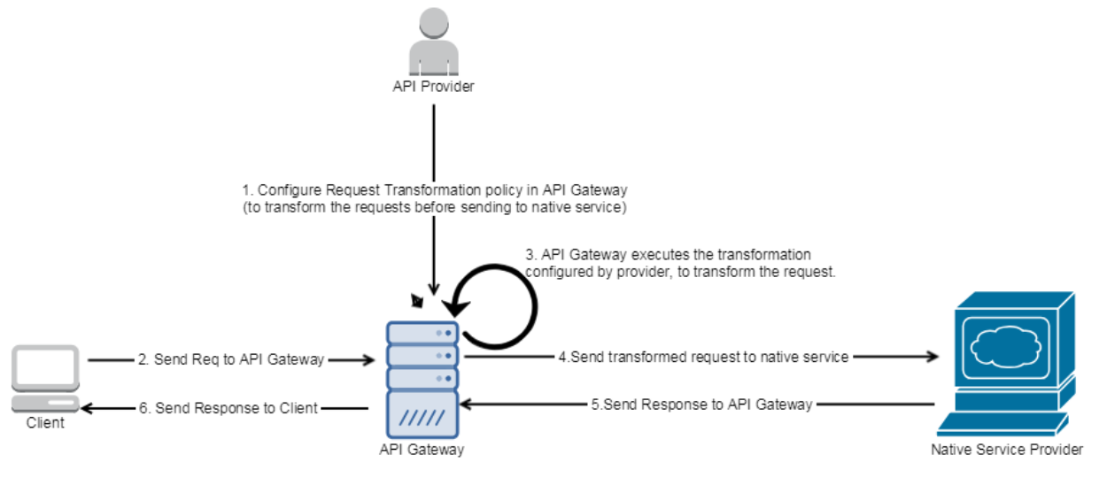

* The Client sends the request to API Gateway
* API Gateway executes the transformations configured by the API Provider, and transform the incoming request
* API Gateway sends the transformed request to the native service
* Native server processes the transformed request and sends the response to API Gateway
* API Gateway forwards the response to client

**Steps to create Request Transformation**

**1**.create flow services and Restresource

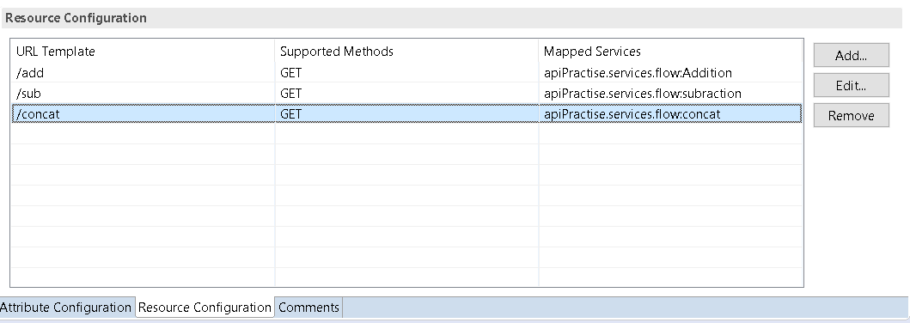

I have created three services and created rest resource for that services

Test your restresource in the soapui make sure it is working

And created a swagger file for the rest resource and save it

**2** .Open API GATEWAY

Import the swagger file which you have saved

After importing edit the API and go to policies

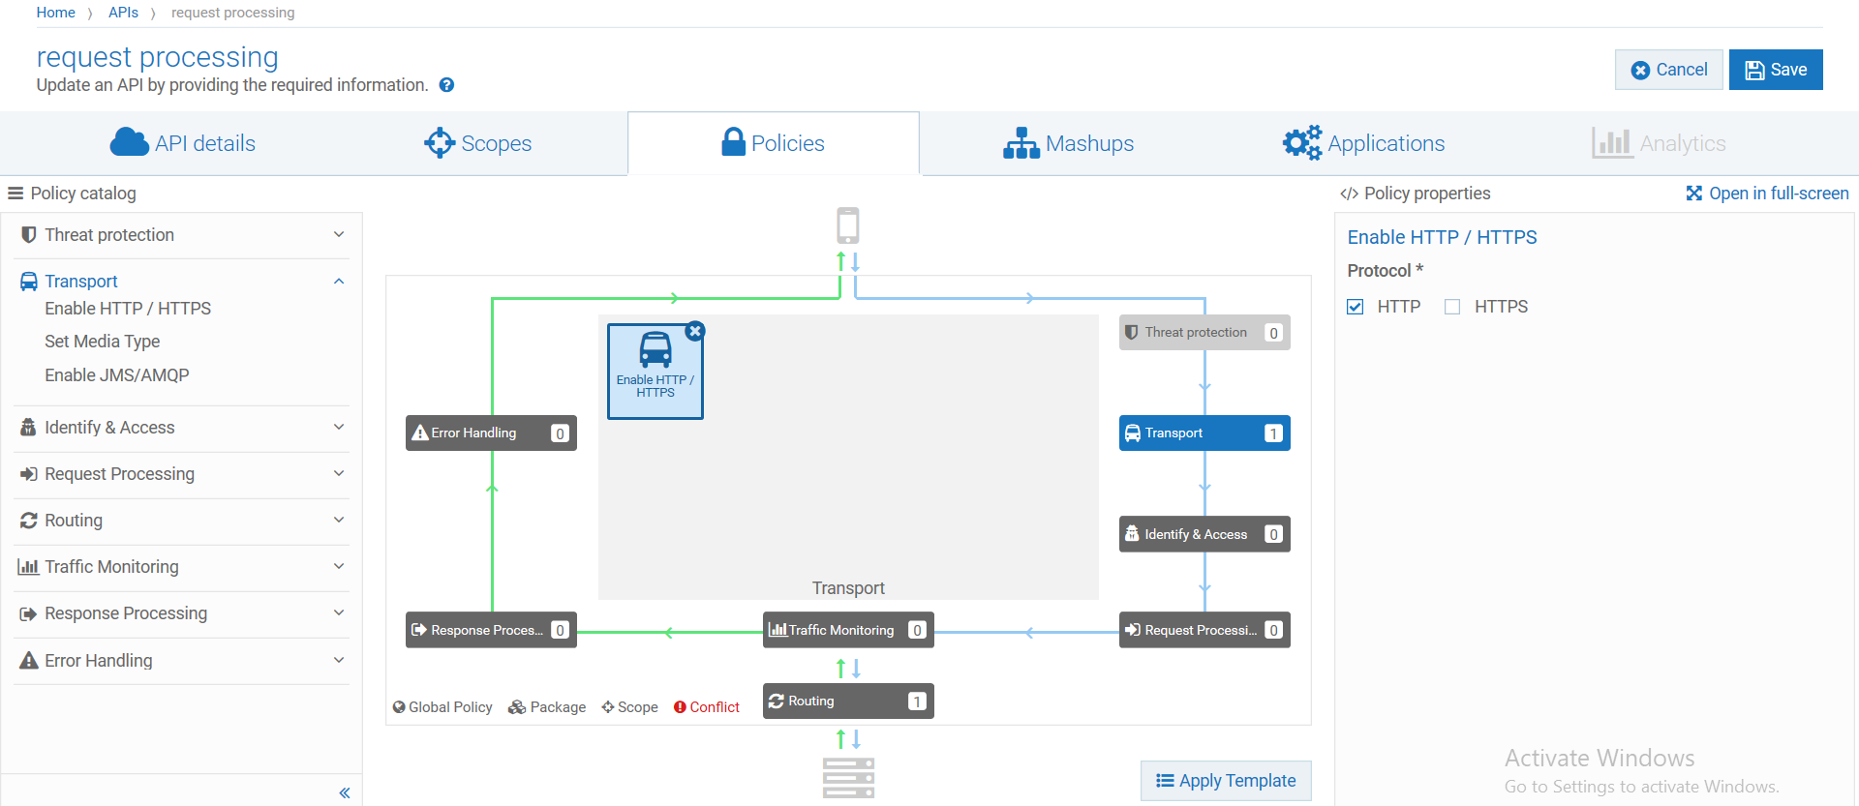

Select Request Processing in that select Request Transformation

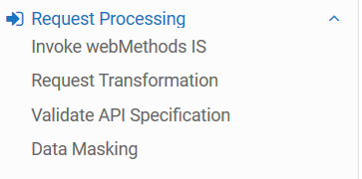

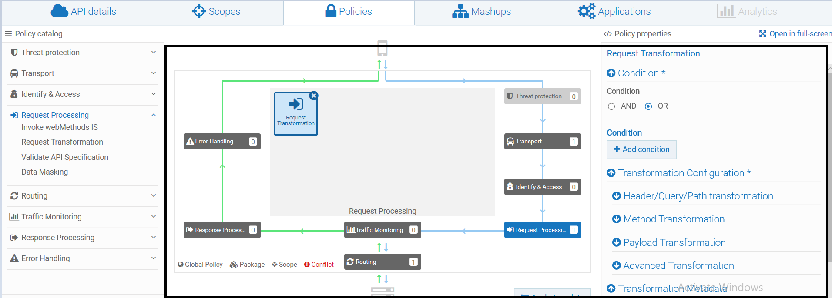you will get all these

Select add condition

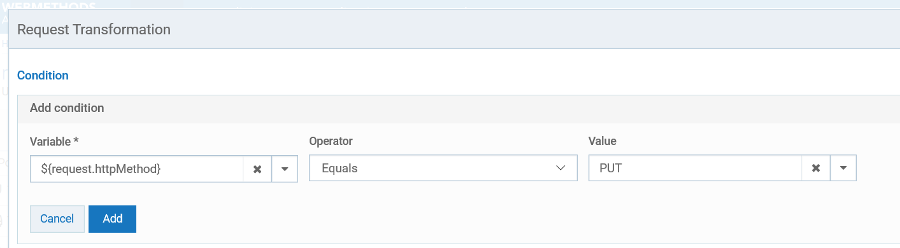

You have to select ${request.httpMethod} which you can see when you search for it and value you have to select value (eg:PUT, GET, POST )if client select POST in testing condition have to transform

It means when client request to API through httpmethod if http method is equals to PUT we have to transform these to a flow service(eg.Add,sub,concat which we created three flow services in IS)

If customer request “PUT” in soapui addition has to perform

**3**.click on Header/Query/Path transformation

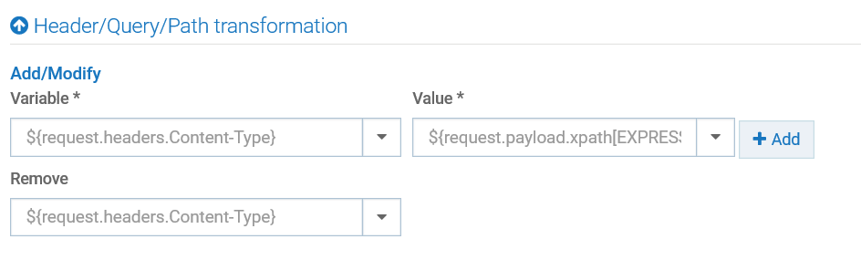

In these select ${request.path} in value which value you want to transform give that (eg add, sub, concat) i had given concat if customer select “PUT” concat operation to perform

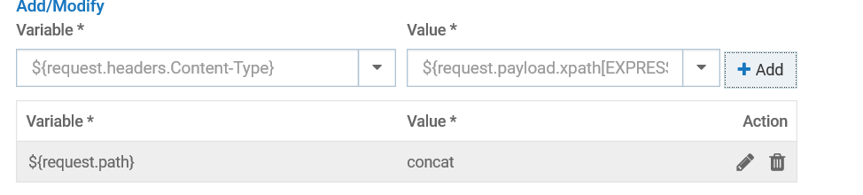

Click Add you will get like this

**4.** In the next step you have to select method Transformation

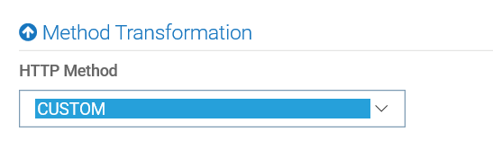

In these step you have to check wheater which method you had selected in IS when creating rest for flow services (or) you can select CUSTOM

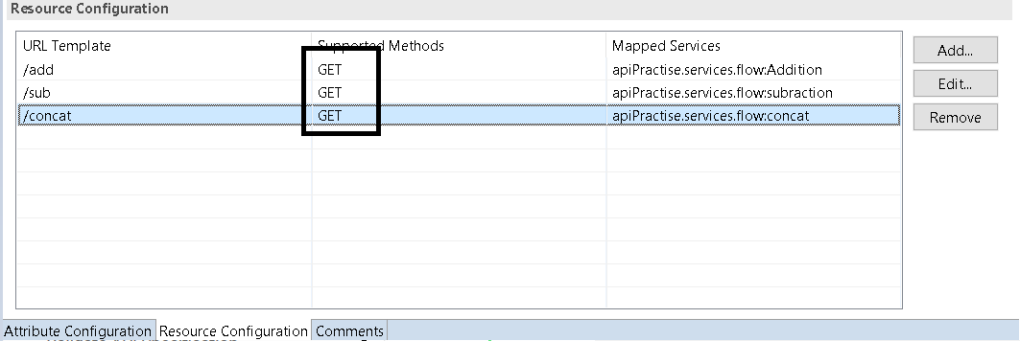

I had selected GET method so i have to give GET in the MethodTransformation

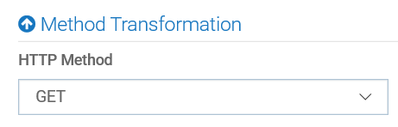

Just save the API

**5.**Go to Resources and methods

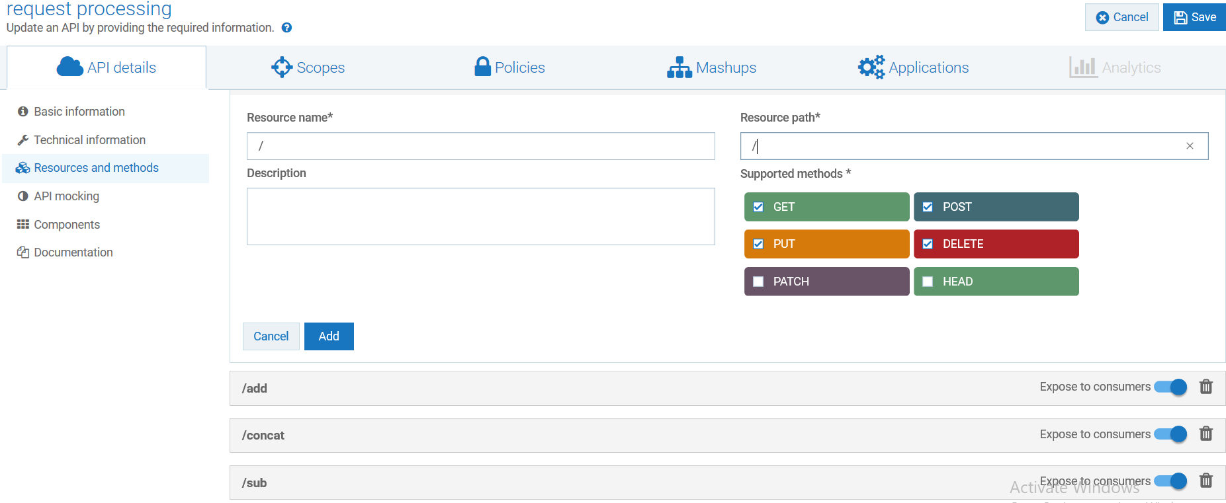

In the Resource name and Resource path give the **“ / ”** and select supported methods which method you are using i have selected GET,POST,PUT,DELETE select the methods supported and delete resource path /add,/concat,/sub delete these

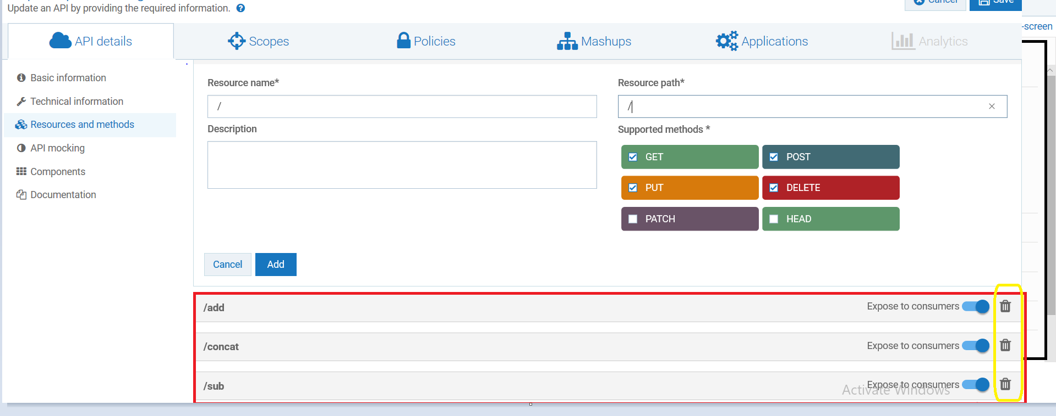

Delete these after that save and activate the Api and take Gateway endpoint(s) and test in the soapui (or) postman

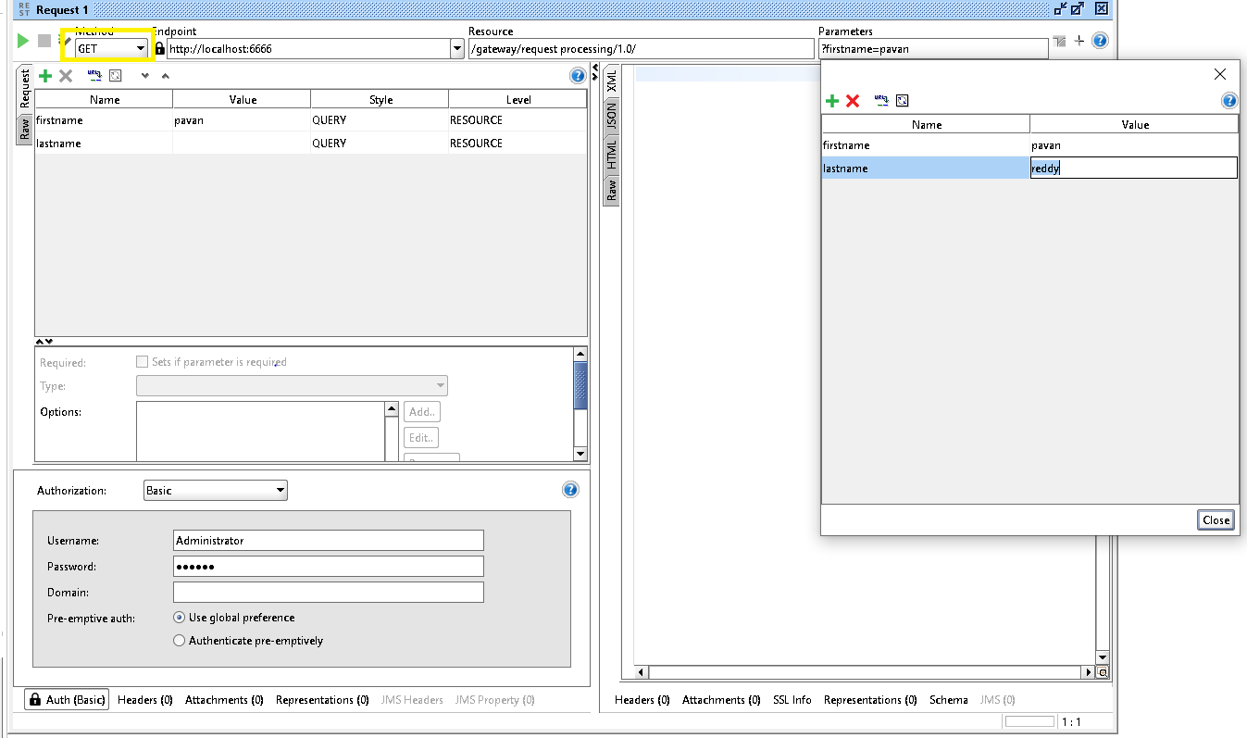

I have taken the Gateway endpoint and testing the soapui we have to write the query in parameters because we selected GET in the IS i have given firstname and lastname according to the inputs in that flow services and select “PUT” in the method which I have highlighted in yellow because if client select PUT concat table has to invoke without giving [http://localhost:6666/gateway/request%20processing/1.0](http://localhost:6666/gateway/request%20processing/1.0/) these is my Gateway endpoint

Which i am testing in soapui

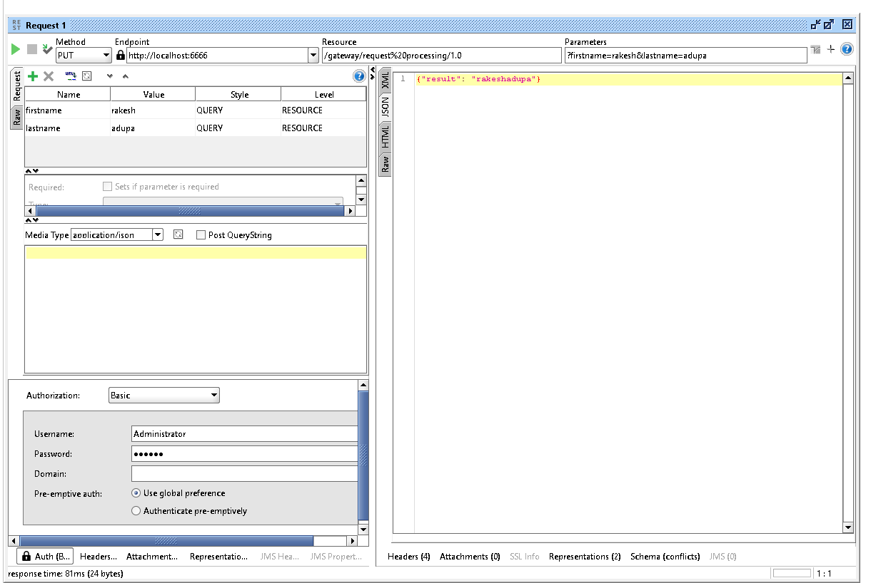

You can see here i am just selecting method name as “PUT” and run the service it is directly invoking concat service